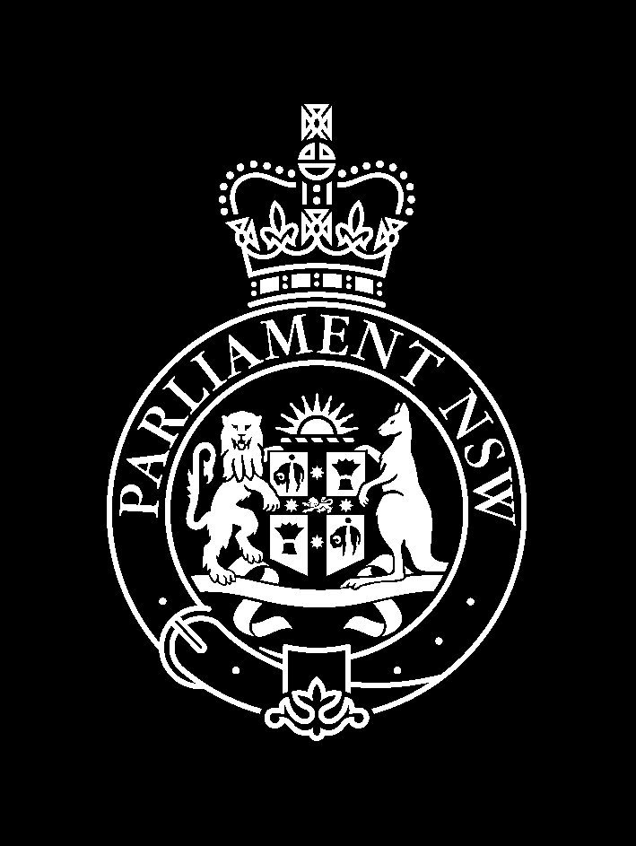
LEGISLATIVE COUNCIL
STANDING COMMITTEE ON SOCIAL ISSUES

NOTICE OF PUBLIC HEARING

INQUIRY INTO
CHILD PROTECTION SERVICES

Thursday 24 October 2002

Waratah Room, Parliament House, Sydney

TIME | WITNESSES
9.30am – 11.00am | Ms Carol Peltola  Consultant and former Executive Director, Child and Family, Department of Community Services

