Standing Committee on STATE DEVELOPMENT
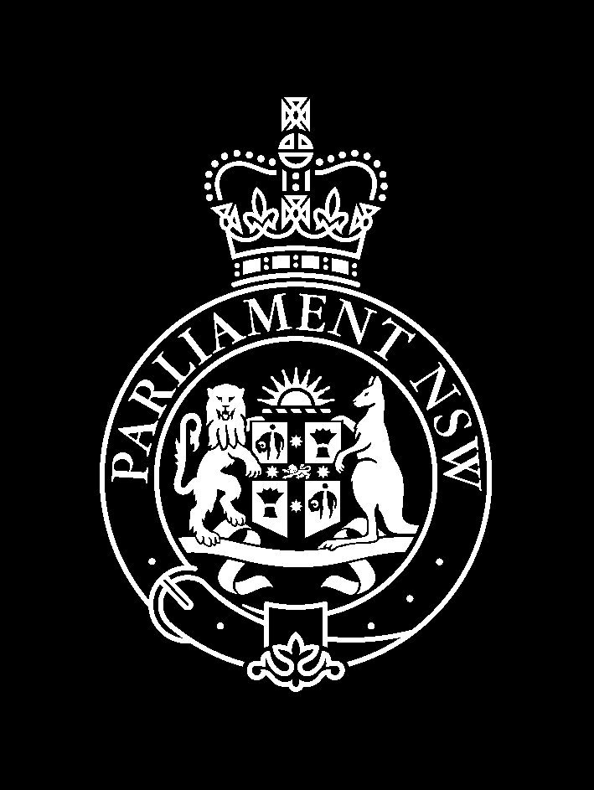
LEGISLATIVE COUNCIL

Public Hearing – Friday 19 September 2003

Room 814/815

Inquiry into Science and its Commercialisation

in New South Wales

Time: | Witness | Position | Organisation:
1.00 pm | Ms Robyn Kruk | Director-General | NSW Department of Health
1.00 pm | Dr Greg Stewart | Deputy Director-General, Public Health  Chief Health Officer | NSW Department of Health
2.30 pm | Close

