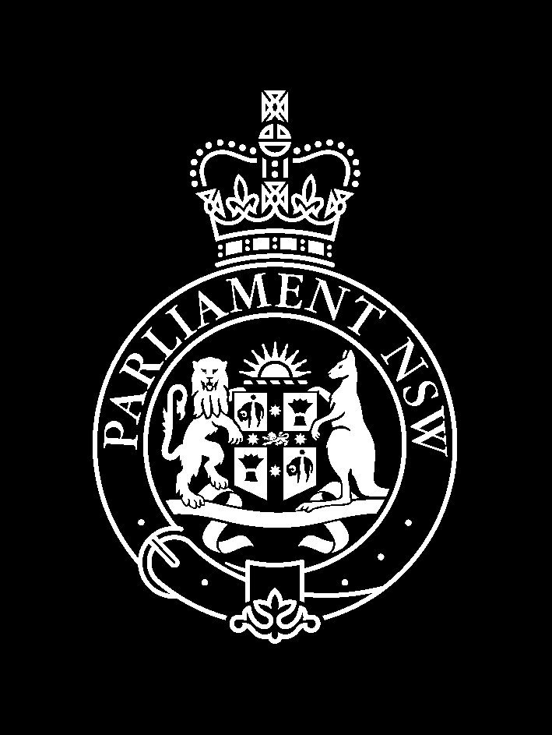
LEGISLATIVE COUNCIL
GENERAL PURPOSE STANDING COMMITTEE NO. 3

NOTICE OF PUBLIC HEARING

Inquiry into Budget Estimates 2007-2008
Friday 26 October 2007
Jubilee Room from 1:30pm

Time | Witness | Position | Organisation
13:30 | Hon Graham West MP | Minister for Gaming and Racing, Minister for Sport and Recreation
13:30 | Mr Bob Adby | Director General | Department of the Arts, Sport and Recreation
13:30 | Mr Chris Priday | Manager, Office of the Director General | Department of the Arts, Sport and Recreation
13:30 | Mr Andrew Kuti | Director | Department of the Arts, Sport and Recreation
13:30 | Mr Brian Farrell | Chief Executive Officer | Casino Control Authority
13:30 | Mr Steve Corbett | Director and Chief Executive Officer | Centennial Park and Moore Park Trust
13:30 | Mr Michael Foggo | Commissioner | Office of Liquor, Gaming and Racing
13:30 | Mr Albert Gardner | Director, Compliance | Office of Liquor, Gaming and Racing
13:30 | Mr John Whelan | Director, Policy | Office of Liquor, Gaming and Racing
13:30 | Mr David Greenhouse | Senior Officer | Office of Liquor, Gaming and Racing
13:30 | Mr Dominic Herschel | Assistant Director, Charities | Office of Liquor, Gaming and Racing
13:30 | Mr John Egan | Director, Programs and Partnerships | NSW Sport and Recreation
13:30 | Ms Wendy Gillet | Director Commercial Services | NSW Sport and Recreation
13:30 | Mr Phil Keady | Property Venues Director | NSW Sport and Recreation

For further information please contact Elizabeth Galton on 9230 2412.

