Table of Contents
Appendix 1 - Case Studies of Potential Base Load Generation Replacement Options 2
Notes: 2
Case 1 - Current NEM Generation mix Direct replacement 4
Case 2 - All coal replaced with combined cycle gas 7
Case 3 - Nuclear Powered Electricity Generation - 50% of NEM Energy 9
Case 4 - Renewable Electricity Generation - 20% of NEM Energy 11
Case 5- Renewable Electricity Generation - 90% of NEM Energy 13
Case 6 - Nuclear power 42% combined cycle gas 40% of NEM Energy 15
Case 7 - Nuclear Powered Electricity Generation - 82% of NEM Energy 17
Appendix 2 - Vital Statistics of Nuclear Generation vs. Renewables Generation on the NEM 19

Appendix 1 - Case Studies of Potential Base Load Generation Replacement Options

Case 1) - The existing national Electricity market of black and brown coal, open and closed cycle gas with limited renewables delivered by hydro, solar and wind.
Case 2) - The replacement of all coal with combined cycle gas for baseload and maintaining the remainder of the NEM energy generation as is.
Case 3) - Use of 50% nuclear energy plus an expanded renewables and pumped storage capacity with substantial backup from fossil fuelled generators operated at lower capacity factors.
Case 4) - Use of renewables consisting of expanded wind and solar plus existing hydro and augmented by pumped storage.
Case 5) - 90% renewables with large scale pumped storage and a small level of open cycle gas generation.
Case 6) - Coal replaced by 42% nuclear energy and 40% combined cycle gas plus pumped storage, hydro, open cycle gas and solar PV.
Case 7) - 82% nuclear generation. Daily peaks are served by pumped storage, solar PV, open cycle gas and hydro.

Notes:
- The full modelling inputs and results are shown for Case 1 to illustrate electricity transmission costing detail. Other cases use similar input methods and details but not all modelling outputs are provided in this Appendix - they are available if requested.
- The tables for each case list the costs of generation for all case results, namely:
  - The System Levelised Cost Of Electricity (SLCOE) which includes the transmission costs specific to that case
  - The final retail cost to consumers and
  - The CO2 abatement cost over and above Case 1 the current NEM average emission level.
- The hydro generator values have been varied in the cases to ensure the hydro generation output under each case remains at 8% of NEM demand.
- The illustrations showing generation output for each case have been limited to a 20 day snapshot from the 1st July 2017 to 21st July 2017 - this is for visual clarity. The full year spectrum is available.
- Pumped storage plays an increasingly important part in both renewable and nuclear cases. The nuclear cases make use of solar PV plus hydro plus pumped storage plus gas to meet the daily peak loads. This can be viewed at finer detail in the following image covering a seven day period.

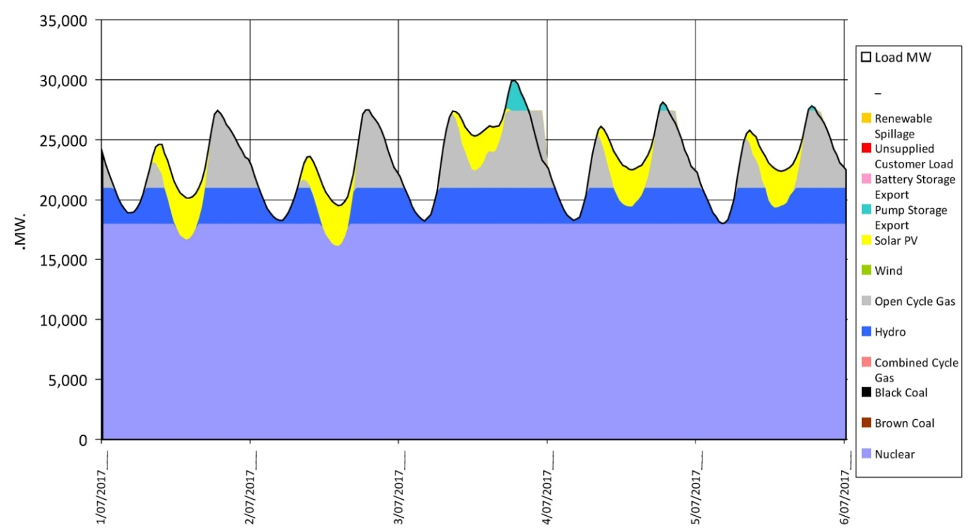
Figure 1 - Seven day snapshot of 82% nuclear power generation case meeting NEM energy
- The models use generator costs obtained from the AEMO "integrated System Plan" July 2018 and its supporting documents. Costs for existing coal power plants used in the model also use these latest values to replicate the current NEM generating costs.
- System Levelised Cost of Electricity (SLCOE) being the final system cost which incorporates all the types of generation in the mix. The commonly quoted Levelised Cost of Electricity (LCOE) is frequently thought of as being a constant value. It is not. The LCOE varies according to how much time the output of a generator actually contributes to the system and of course, how much of its energy is either curtailed or wasted. The output from the model developed by Dr Robert Barr fully accounts for the varying LCOE of each generator and adds an allowance for additional transmission to produce a final system cost or SLCOE

Case 1 - Current NEM Generation mix Direct replacement

GenTypeDesc | Installed MW | Storage Days
Nuclear | 0
Brown Coal Supercritical | 3,000
Black Coal Supercritical | 14,000
Combined Cycle Gas | 2,000
Hydro | 4,200
Open Cycle Gas | 10,500
Wind | 3,500
Solar PV | 323
Pump Storage | 0 | 2
Battery Storage | 100 | 0.06
Table 1 - Generator Mix in Current NEM Energy output

 | Carbon Intensity |  | 0.83 | Tonnes CO2/MWh
Parameter | Discount | 3.00% | 6% | 10% | 12.00%
Generation | $/MWh | $ 55.00 | $ 64.69 | $ 78.83 | $ 86.03
SLCOE | $/MWh | $ 59.01 | $ 68.73 | $ 83.00 | $ 90.06
Domestic Retail | $/MWh | $201.00 | $210.98 | $225.11 | $232.31
Abatement Cost | $/Tonne CO2 | NA | NA | NA | NA

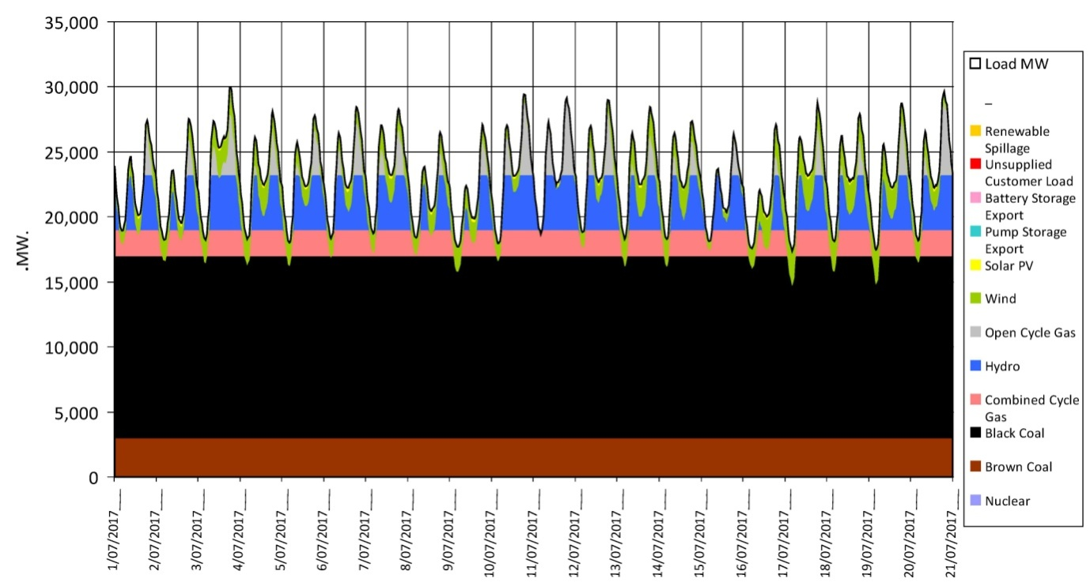
Figure 2 - Current Base NEM Energy Mix in 2017

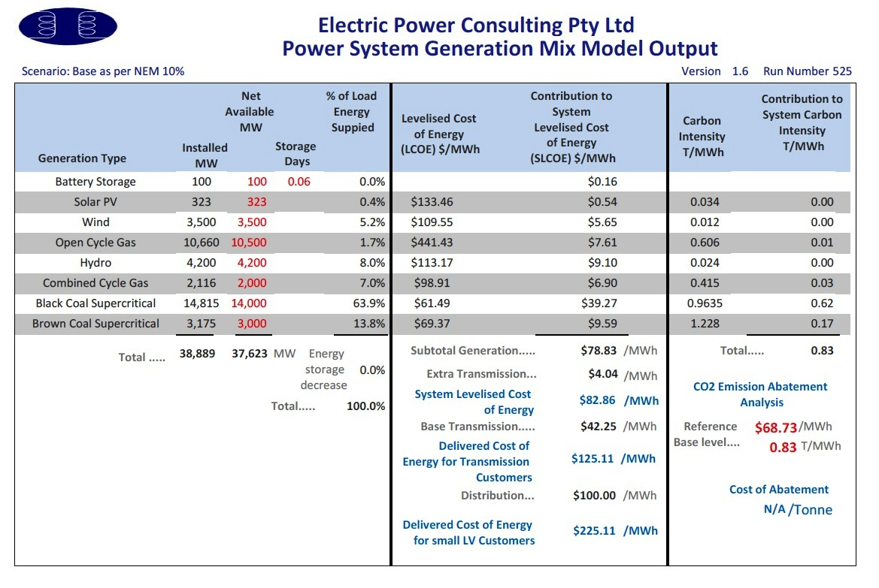
Figure 3 - EPC model output for current NEM Energy mix 2017

Case 2 - All coal replaced with combined cycle gas
GenTypeDesc | Installed MW | Storage Days
Nuclear | 0
Brown Coal Supercritical | 0
Black Coal Supercritical | 0
Combined Cycle Gas | 18000
Hydro | 3,000
Open Cycle Gas | 6,450
Wind | 0
Solar PV | 4,000
Pump Storage | 3,000 | 2
Battery Storage | 100 | 0.06
Table 2 - Generator mix with All Coal replaced by Combined Cycle gas
 | Carbon Intensity |  | 0.373 | Tonnes CO2/MWh
Parameter | Discount | 3.00% | 6% |  | 10% | 12.00%
Generation | $/MWh | $ 87.13 | $ 93.63 |  | $102.98 | $107.72
SLCOE | $/MWh | $ 89.84 | $ 96.35 |  | $105.70 | $110.43
Domestic Retail | $/MWh | $232.09 | $238.60 |  | $247.95 | $252.68
Abatement Cost | $/Tonne CO2 | $ 68.02 | $ 60.92 |  | $ 50.08 | $ 44.95

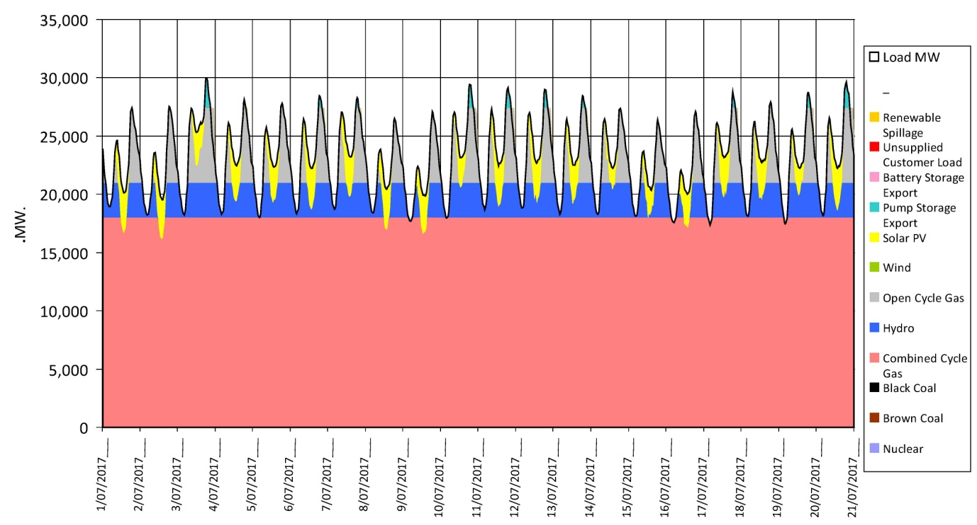
Figure 4 Combined Cycle Gas replaces All Coal Generator Mix on NEM

Case 3 - Nuclear Powered Electricity Generation - 50% of NEM Energy
GenTypeDesc | Installed MW | Storage Days
Nuclear | 10,800
Brown Coal Supercritical | 1,200
Black Coal Supercritical | 5,600
Combined Cycle Gas | 800
Hydro | 3,400
Open Cycle Gas | 8,000
Wind | 1,400
Solar PV | 2,500
Pump Storage | 3,000 | 2
Battery Storage | 100 | 0.06
Table 3 - Generator Mix for 50% Nuclear Energy on the NEM

 | Carbon Intensity |  | 0.35 | Tonnes CO2/MWh
Parameter | Discount | 3.00% | 6% |  | 10% | 12.00%
Generation | $/MWh | $ 62.55 | $ 78.00 |  | $ 99.23 | $109.91
SLCOE | $/MWh | $ 65.58 | $ 80.72 |  | $102.26 | $112.93
Domestic Retail | $/MWh | $208.00 | $223.00 |  | $244.51 | $255.18
Abatement Cost | $/Tonne CO2 | $ 13.90 | $ 25.39 |  | $ 41.06 | $ 48.41

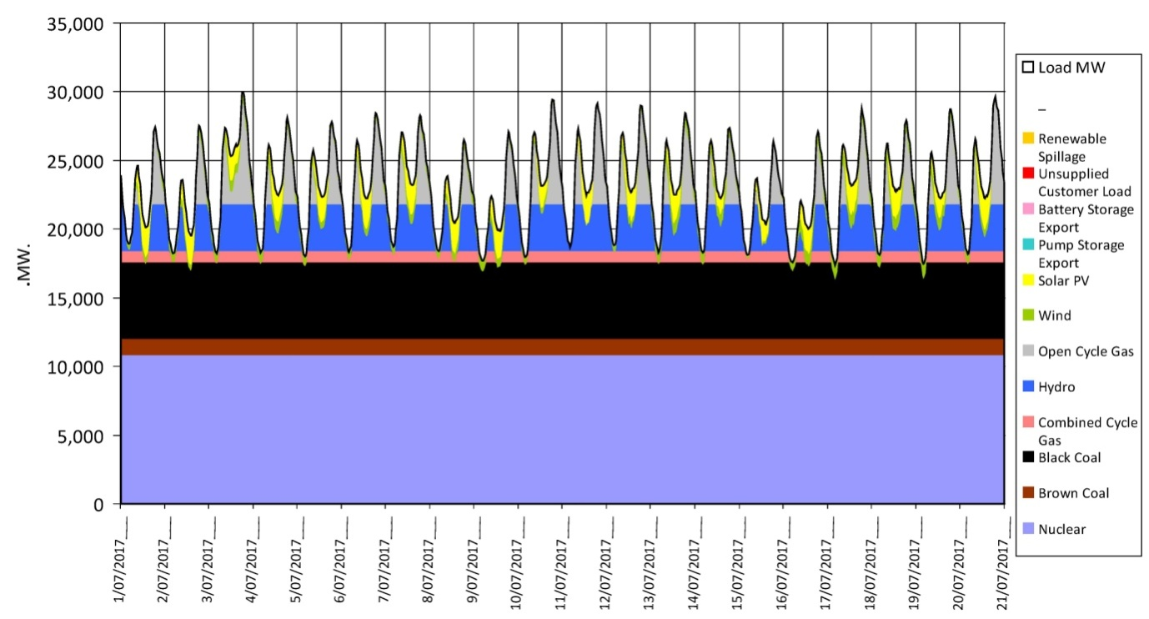
Figure 5 - Nuclear Power Generation 50% of NEM Energy

Case 4 - Renewable Electricity Generation - 20% of NEM Energy
GenTypeDesc | Installed MW | Storage Days
Nuclear | 0
Brown Coal Supercritical | 2,500
Black Coal Supercritical | 9,750
Combined Cycle Gas | 2,000
Hydro | 2,200
Open Cycle Gas | 13,800
Wind | 3,000
Solar PV | 5,500
Pump Storage | 1,500 | 2
Battery Storage | 100 | 0.06
Table 4 - Generator Mix for 20% Renewable Energy on the NEM

Carbon Intensity |  | 0.7 | Tonnes CO2/MWh
Parameter | Discount | 3.00% | 6% | 10% | 12.00%
Generation | $/MWh | $ 66.37 | $ 74.94 | $ 87.36 | $ 93.70
SLCOE | $/MWh | $ 73.76 | $ 82.33 | $ 94.75 | $101.09
Domestic Retail | $/MWh | $216.01 | $224.58 | $237.00 | $243.34
Abatement Cost | $/Tonne CO2 | $118.55 | $109.34 | $ 94.48 | $ 88.67

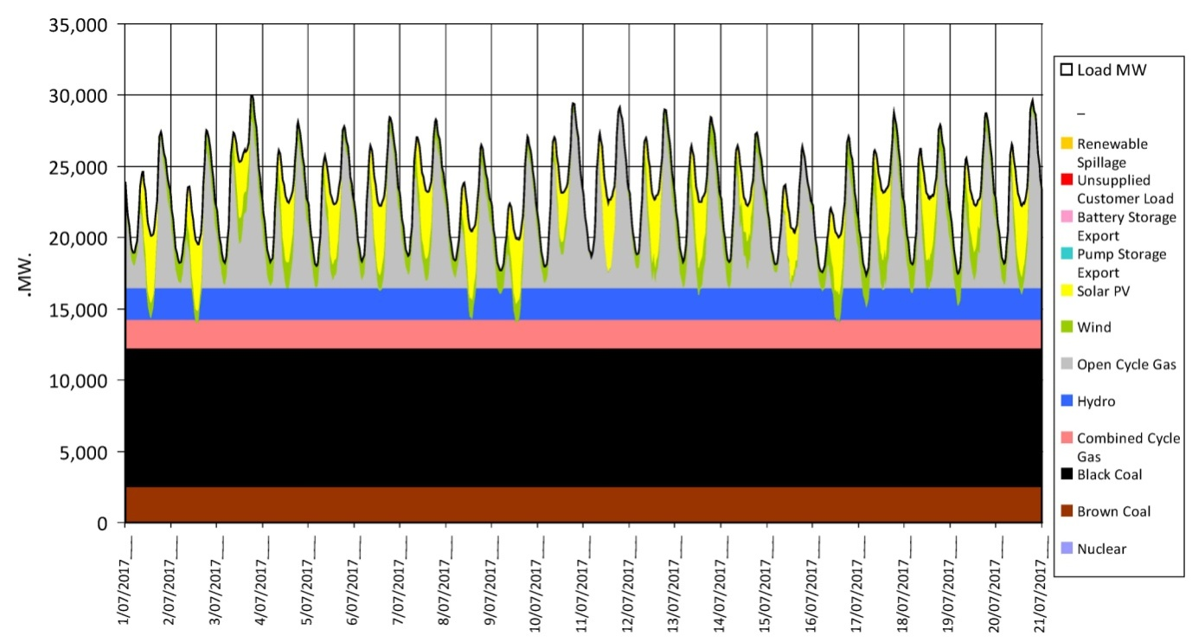
Figure 6 - Renewables 20% of NEM Energy Generation

Case 5- Renewable Electricity Generation - 90% of NEM Energy

GenTypeDesc | Installed MW | Storage Days
Nuclear | 0
Brown Coal Supercritical | 0
Black Coal Supercritical | 0
Combined Cycle Gas | 0
Hydro | 4,800
Open Cycle Gas | 18,000
Wind | 50,000
Solar PV | 55,000
Pump Storage | 5,000 | 2
Battery Storage | 100 | 0.06
Table 5 - Generator Mix for 90% Renewable Energy on the NEM

Carbon Intensity |  | 0.08 | Tonnes CO2/MWh
Parameter | Discount | 3.00% | 6% | 10% | 12.00%
Generation | $/MWh | $151.19 | $172.81 | $203.33 | $218.92
SLCOE | $/MWh | $272.44 | $294.06 | $324.58 | $340.18
Domestic Retail | $/MWh | $414.69 | $436.31 | $466.83 | $482.43
Abatement Cost | $/Tonne CO2 | $286.60 | $302.58 | $324.40 | $335.86

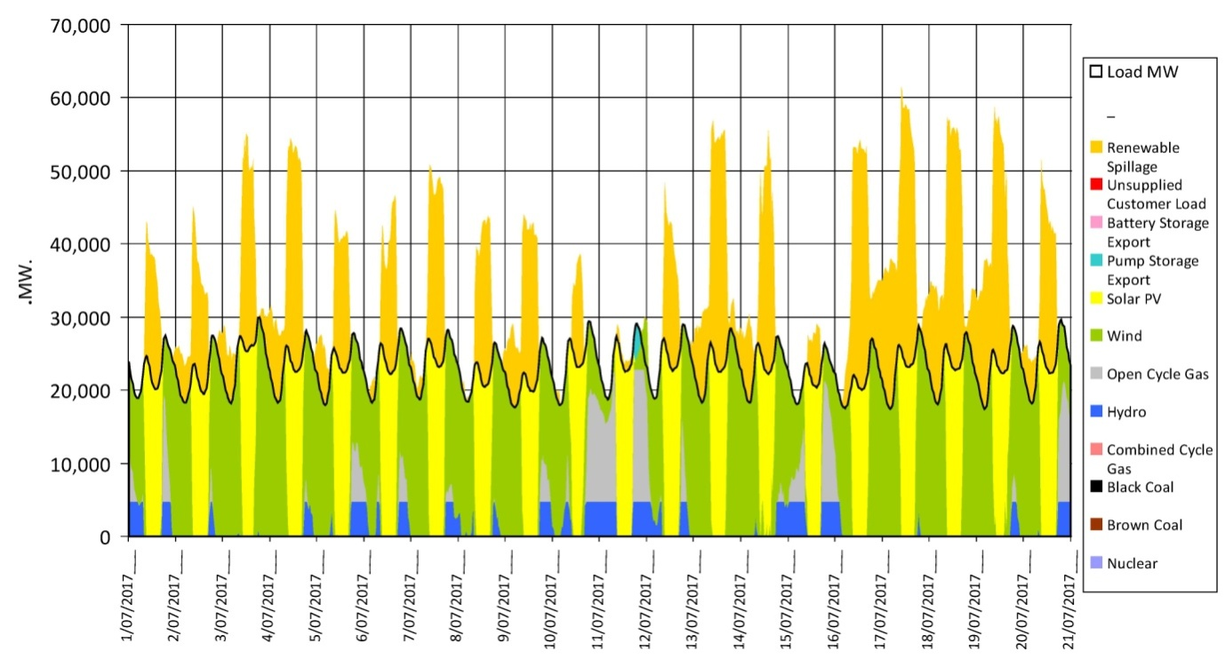
Figure 7 Renewables Generation at 90% of NEM Energy

Case 6 - Nuclear power 42% combined cycle gas 40% of NEM Energy
GenTypeDesc | Installed MW | Storage Days
Nuclear | 9,000
Brown Coal Supercritical | 0
Black Coal Supercritical | 0
Combined Cycle Gas | 9,000
Hydro | 3,000
Open Cycle Gas | 6,450
Wind | 0
Solar PV | 4,000
Pump Storage | 5,000 | 2
Battery Storage | 100 | 0.06
Table 6 - Generator Mix for 42% Nuclear and 40% Combined Cycle Gas Energy on the NEM

Carbon Intensity |  | 0.21 | Tonnes CO2/MWh
Parameter | Discount | 3.00% | 6% | 10% | 12.00%
Generation | $/MWh | $ 77.33 | $ 90.00 | $107.97 | $116.86
SLCOE | $/MWh | $ 80.05 | $ 92.72 | $110.69 | $119.58
Domestic Retail | $/MWh | $222.30 | $234.97 | $252.94 | $261.83
Abatement Cost | $/Tonne CO2 | $34.07 | $38.86 | $44.83 | $47.79

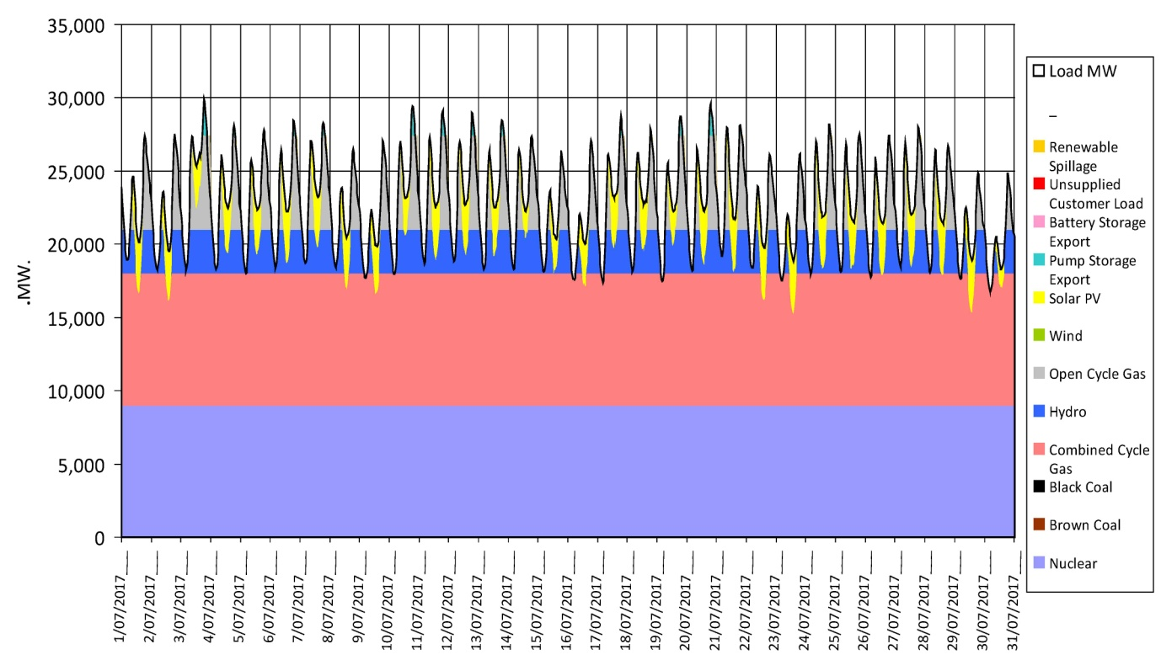
Figure 8 - Total NEM Energy with 42% Nuclear and 40% combined Cycle Gas

Case 7 - Nuclear Powered Electricity Generation - 82% of NEM Energy
GenTypeDesc | Installed MW | Storage Days
Nuclear | 18,000
Brown Coal Supercritical | 0
Black Coal Supercritical | 0
Combined Cycle Gas | 0
Hydro | 3,000
Open Cycle Gas | 6,450
Wind
Solar PV | 4,000
Pump Storage | 5,000 | 2
Battery Storage | 100 | 0.06
Table 7 - Generator mix for 82% of Nuclear Energy on the NEM

 | Carbon Intensity |  | 0.05 | Tonnes CO2/MWh
Parameter | Discount | 3.00% | 6% |  | 10% | 12.00%
Generation | $/MWh | $ 68.13 | $ 86.97 |  | $113.55 | $126.59
SLCOE | $/MWh | $ 70.85 | $ 89.96 |  | $116.27 | $129.31
Domestic Retail | $/MWh | $213.10 | $231.94 |  | $258.52 | $271.56
Abatement Cost | $/Tonne CO2 | $ 15.22 | $ 26.96 |  | $ 42.79 | $ 50.49

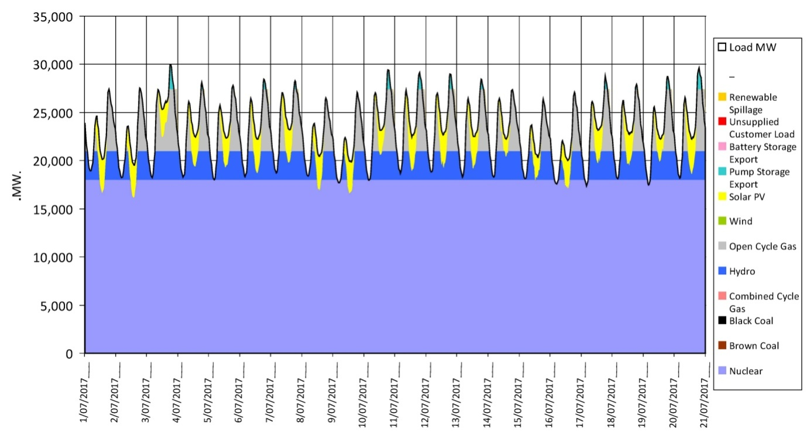
Figure 9 - Nuclear Power Generation 82% of NEM Energy

Appendix 2 - Vital Statistics of Nuclear Generation vs. Renewables Generation on the NEM
The following five graphs show the comparison of:
- System Levelised Cost of Electricity (SLCOE) being the final system cost which incorporates all the types of generation in the mix. The commonly quoted Levelised Cost of Electricity (LCOE) is frequently thought of as being a constant value. It is not. The LCOE varies according to how much time the output of a generator actually contributes to the system and of course, how much of its energy is either curtailed or wasted. The output from the model developed by Dr Robert Barr fully accounts for the varying LCOE of each generator and adds an allowance for additional transmission to produce a final system cost or SLCOE.
- Retail Electricity. This graph compares the final cost of the power at the wall for domestic and commercial customers on the NEM. A separate data base exist for Energy for large scale transmission customers such a aluminium smelters however in the interests of brevity this has not been included in this paper but is available for discussion.
- Carbon Abatement. The three aims of our energy renewal are to achieve low cost, reliability and low carbon emissions. The final graph shows the vastly lower cost of carbon abatement (reduction) in terms of A$/tonne of carbon dioxide obtainable from nuclear energy compared to renewables. This performance is verified each day in France, Sweden, South Korea and Switzerland.
- Selected Energy options ranked by retail price to small low voltage consumers
- Selected Energy options ranked by Abatement Cost
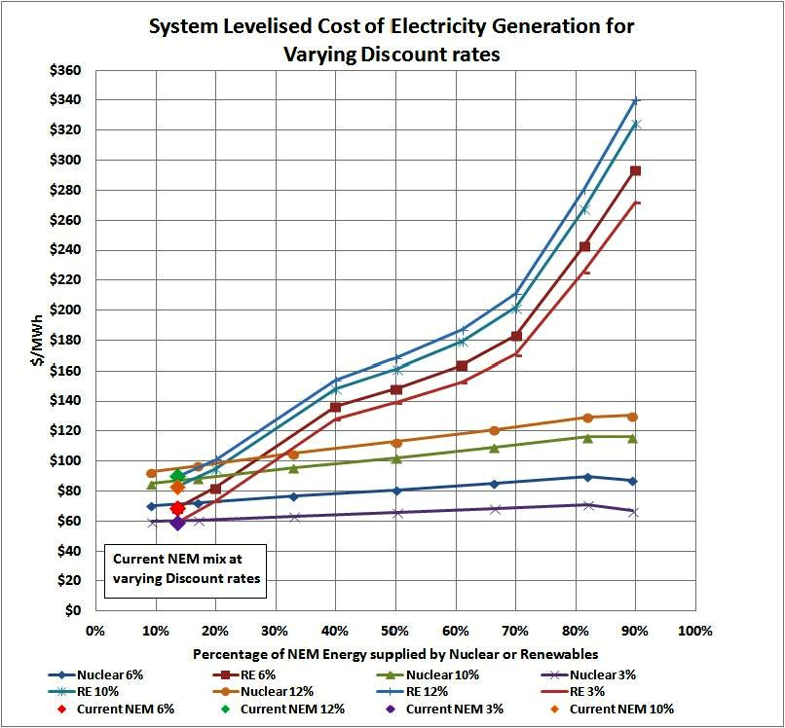
Figure 10 - System Levelised Cost of Electricity Generation,
Nuclear compared to Renewables at varying discount rates

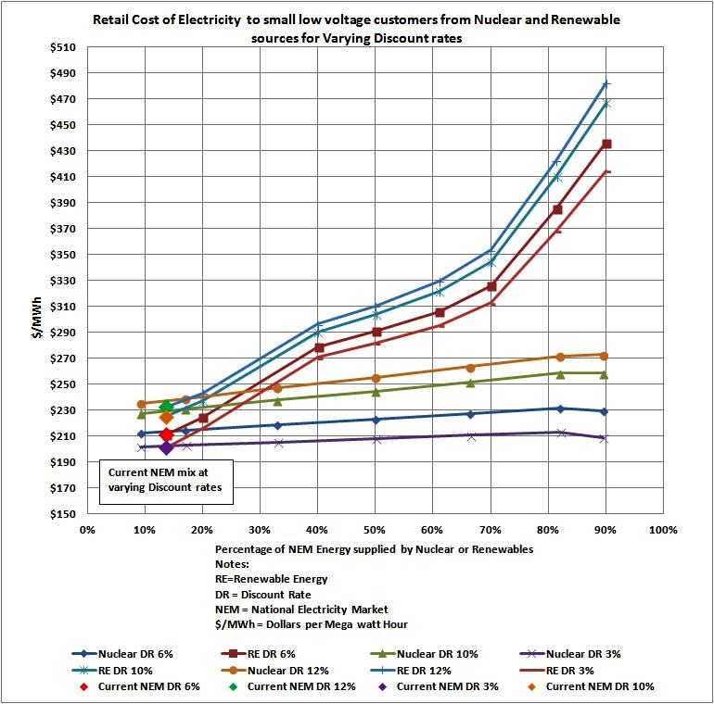
Figure 11 - Comparison of Retail costs of electricity for small, low voltage customers,
Nuclear vs Renewables

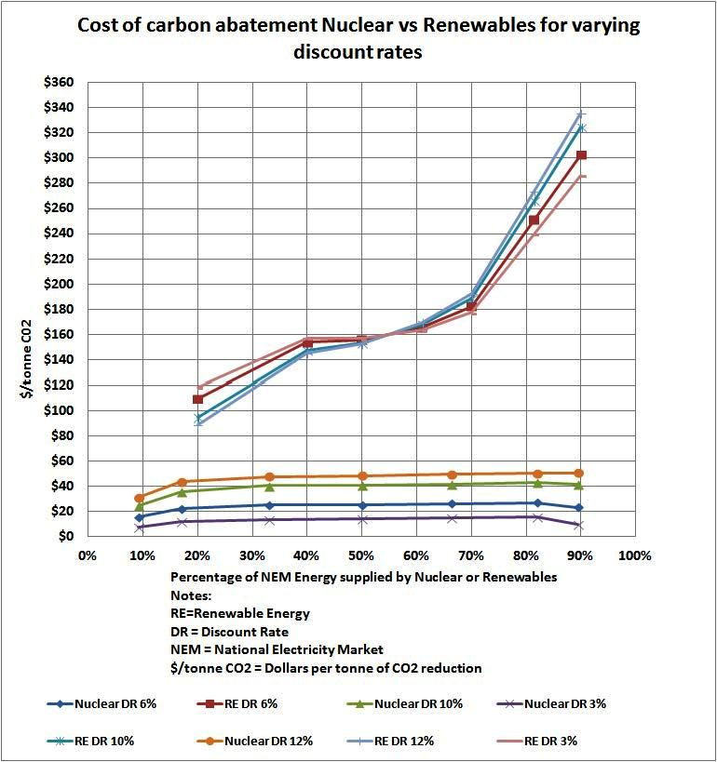
Figure 12 - Comparison of Nuclear and Renewable Energy Carbon Abatement
costs at varying discount rates.

Figure 13 - Selected Generating options ranked on Retail price

Figure 14 - Selected generating Options ranked on carbon abatement cost

