**Online questionnaire summary report**

**Inquiry into Foundational and Disability Supports Available for Children and Young People in New South Wales**

## Background

As part of its inquiry into Foundational and Disability Supports Available for Children and Young People in New South Wales, the Select Committee on Foundational and Disability Supports Available for Children and Young People in New South Wales provided an online questionnaire to encourage public participation in the inquiry in an efficient and accessible way.

The questionnaire was not intended as a statistically valid, random survey. Respondents self-selected in choosing to participate. This means that respondents are unlikely to be a representative sample of the New South Wales population. Instead, the responses represent a sample of interested members of the public who volunteered their time to have a say.

The questionnaire was complementary to and did not replace the usual submission process. The submissions process was available to individuals and organisations who wished to provide a more detailed response to the inquiry's terms of reference. In this regard, some respondents may have completed the questionnaire and also made a submission.

The online questionnaire was open from 28 November 2024 until 27 April 2025. The committee received 100 responses.

This report summarises the responses received by participants to both the quantitative and qualitative questions posed. These responses will inform the committee's views throughout the inquiry.

## Questions asked

In this questionnaire, participants were asked 20 questions about their views and experiences with foundational and disability supports and services in NSW. The questions were divided across three sections, and included a combination of multiple-choice questions (controlled input) and open answer questions (free text).

· Section 1 (questions 1 to 7) contained administrative questions to collect basic details, such as name, location and age of the child or young person

· Section 2 (questions 8 to 16) covered questions about the services and supports available for and used by children and young people

· Section 3 (questions 17 to 20) focused on views about the services and allowed the questionnaire participant to provide any further feedback.

The full list of questions is at Appendix 1.

A summary of responses and a sample of the answers are provided below which represent the variety of views expressed by the participants.

# Responses to questions

## Background information

93 questionnaire respondents were a parent, carer or guardian of a child with a developmental concern, delay, difference or disability. 3 were a child or young person with disability or difference, and 4 were adults with disability.

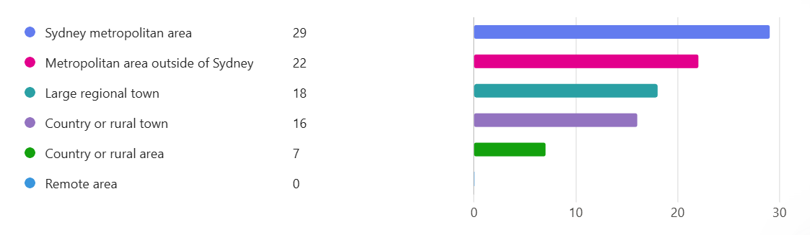92 respondents lived in NSW. Respondents predominantly lived in the Sydney metropolitan area (29) or in a metropolitan area outside of Sydney (22). 26 respondents came from the Illawarra or South Coast region. A full breakdown of respondent locations is provided in the graph below.

Respondents provided information about children or young people from a range of ages. The median age was 9 (11% of respondents). The youngest child was 9 months old, and the oldest young person was 25.

## Section 2 – services and supports available

Question 8: Is the child or young person eligible for NDIS funding?

* Yes: 65
* No: 27

Question 9: Does the child or young person have a formal diagnosis of a developmental concern, delay, difference, or disability from a doctor or health specialist?

* Yes: 79
* No: 13

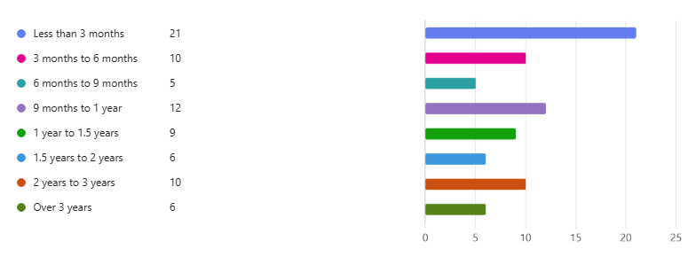Question 10: How long did it take to obtain a formal diagnosis for the child or young person?

Question 11: Were there diagnostic services in your local area to obtain a diagnosis for the child or young person?

* Yes: 57
* No: 22

Question 12: How long did you have to travel to access diagnostic services?

* Under 1 hour: 50
* 1 hour to 2 hours: 14
* 2 hours to 3 hours: 8
* More than 3 hours: 7

Question 13: Does the child or young person currently have support services for their developmental concern, delay difference or disability?

* Yes: 66
* No: 26

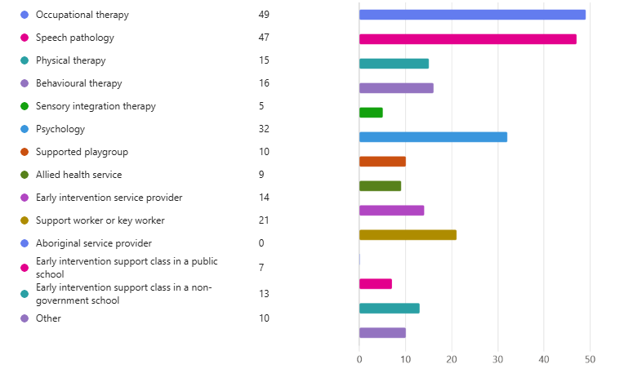Question 14: What type of supports and services has the child or young person engaged with?

Question 15: Were any of those supports covered by the NDIS?

* Yes: 50
* No: 16

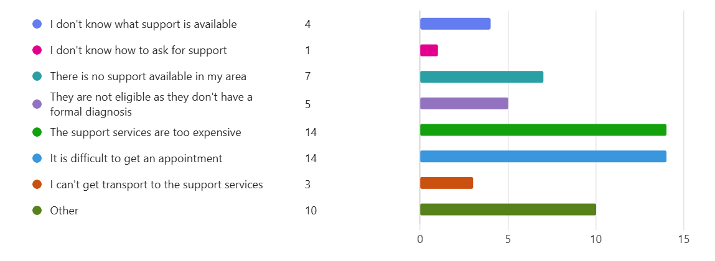Question 16: Why does the child or young person not receive support services?

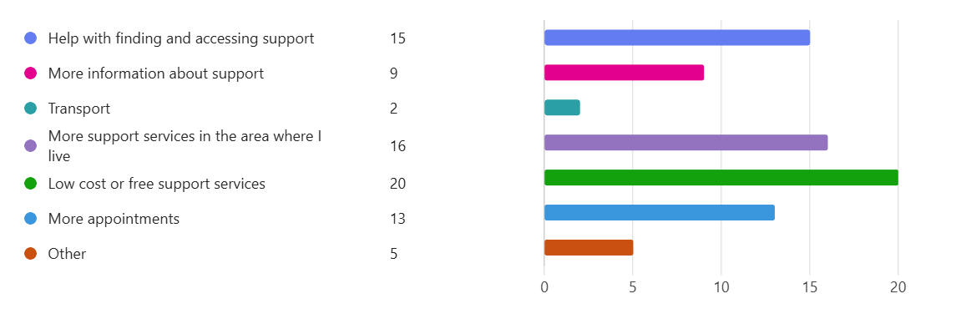Question 17: Tell us what you think would help improve access to support for the child or young person?

## Section 3 – feedback about the services

Question 18: Tell us how important you think support services are for the health, development and wellbeing of the child or young person.

A total of 88 responses were received for this question. Respondents emphasised how crucial early interventions and supports are for a child's development. Many respondents explained how their children would not have developed as well if they had not received early childhood supports. Support services were described as 'crucial', 'vital', 'extremely important', 'paramount', 'invaluable', 'absolutely critical', 'fundamental', 'essential' and 'integral'. Some respondents described their negative experiences, due to missing out on supports or having a frustrating experience with the available services.

A sample of comments are set out below, according to theme.

*Positive experiences with support services*

* 'Our Key Worker has been a life saver. They have helped us navigate every aspect of our child's needs educational, social, community and in the home. They provided a sounding board and advocacy support and have been instrumental in keeping all our supports heading in the right direction for proper outcomes. We could not have navigated these spaces without the support of our Key Worker (Educator).'
* 'Our children's lives have totally changed due to the supports they have received. The eldest is now thriving and starts full-time employment next week. The second is substantially more functional and enjoying working part-time. Neither would have been able to achieve this or live out of home without the supports they received. It is essential that other families like our continue to be able to access support, even if they no longer meet access criteria for the NDIS.'
* 'We have had NDIS for four years, since my son was diagnosed, and in that time has had the same OT throughout. She has been an amazing advocate for him and it has been wonderful to have someone see the journey of how this young person has changed and grown and learnt over time. Psychology has been incredibly helpful for enabling our entire family unit to learn about how best to support him and develop better skills in emotional regulation and behaviour management. They have both been lifelines through some of the most difficult times in our lives. NDIS also supports group therapies, which more than anything else, has changed our son's sense of self worth and social engagement. If you asked him, he would tell you that his favourite things to do all week are his group therapies with other disabled children, particularly those led by mentors with lived experience of disability. This has meant so much to him because the peer support means that he feels that his life experience is normalised, he does not feel strange or different from other children, he feels genuinely part of a community. These groups have changed his life and outlook about how he envisages his future, because he now has friends and mentors who he looks up to.'

*Building family skills and capacity*

* 'Support services for my child have enabled him to participate in society alongside his typically developing peers. Furthermore, it has allowed our family to learn skills and techniques in order to best support his overall wellbeing and growth.'
* 'The early intervention support that we have received for Daniel have been integral to our whole family learning how to adapt to Daniel's autism and intellectual disability, while also giving Daniel a space where he can be around other children who have similar developmental needs and delays. We have felt supported and understood in this environment, as opposed to feeling often embarrassed within the greater community and it has helped us understand Daniel's conditions and seek out resources and supports to assist us on his journey.'
* 'I am a high school teacher so I have some understanding of ASD, child development and navigating the education system. Without the support of our allied health team, even I would have had terrible struggles to manage, so I fear for parents who are not as well educated and supported as me.'

*Negative experiences regarding supports*

* 'My son missed out on early intervention supports which would have been great for him in his early years of schooling. That put him behind and we spent years trying to get a diagnosis which meant he fell further and further behind his peers and was denied adequate supports in school once he had a diagnosis. This meant that he eventually became suicidal and started self harming after his self esteem and self confidence was stripped down by the mainstream education system. My son was left drowning and I had no choice but to take him out of the system and educate at home. After that, my son never looked back and eventually graduated with his HSC certificate once I found a fully inclusive private senior college to put him in for year 11 and 12 that put his mental health and well being first.'
* 'The support services unfortunately is a business operating on profit. I had to pay privately for sometime and they make you sign agreements. You pay for an hour including 15 minutes for notes. You don't have the right to access the notes and its all like this. Therapists can leave regularly and then you start with a new one who does not seem to read the notes which makes it likely that there were no notes on file.'
* 'My daughter has severe speech delay and emotional regulation challenges, but because she is a girl the paediatrician is not willing to diagnose her. This means we have been on a long journey trying to get Early Intervention Funding for her to access services. It has been at least two years now that we know she needs services but we are still waiting…Today I heard back from [the disability service provider] and they have informed us that the speech report we applied with in May last year is now out of date so we need a new one in order to continue with our application for funding. Once again, we need to pay for a new report in order to try to get funding we have known she has needed for so long now. She already has an OT report but they have now also requested a psychology report to support our application. We just hope that one day she will get the support she so needs and deserves. In the meantime, she just gets older and her speech continues to be so far behind her peers and her anxiety worsens as she becomes more and more aware of how she in unable to communicate with people outside the home. Preschool anxiety and social skills are more and more of an issue and snowballing as she doesn't get the treatment she needs.'

*Prohibitive costs*

* 'It is imperative that my son have support for his diagnosis however we are financially unable to give him the full support that he needs paying privately at $220/hr.'
* 'It's vital that the public continue to fund the creation of these expert reports, which are used to determine how much funding participants get in their NDIS plans. If we don't, we're risking a system where only the wealthy come away with adequate NDIS plans, while non-wealthy children lose access to vital support services'
* 'My husband and I have had the means to hire a support worker for our son. Most people would not be able to do this. Without our support worker, I would not be able to work, my husband's ability to work would be impacted and our son would not have the opportunities he has in terms of interaction, fun and social inclusion that our support worker facilitates for him.'

*Lack of access or long waitlists*

* 'We moved from a regional area to Sydney metro in early 2021 to access medical and diagnostic services because the wait lists were too long and one of our two children had signs of possibly serious neurological illness. We initially spent our savings and took out a personal loan to pay medical expenses and to start early intervention. Gaining access to NDIS was slow.'
* 'Young children in our area are waiting more than 12 months to access services. Developmentally they are falling further behind while they wait and it is putting pressure on families and schools.'
* 'Living in a rural area we have no access to dyslexia support.'

Question 19: Would you be willing to meet with the committee to speak with them about your experiences?

* Yes: 66
* No: 26

Question 20: Is there anything else you want to tell us?

There were 56 responses to this question. Respondents generally responded by describing difficulties they have faced accessing supports. A sample of comments are set out below, according to theme.

*Too much complexity/lack of clarity about the system*

* 'The national service that is meant to support some of the most vulnerable people in our country is too complex and difficult to navigate for a population of people who often need support with far more accessible government services.'
* 'The complexity and financial cost of seeking support outside the NDIS for my son is prohibitive. The NSW health system is not resourced to provide the support needed in a timely fashion to meet early intervention requirements, and it is extremely difficult to navigate even for a university educated person for whom English is my first language.'
* 'It’s extremely isolating being a parent of a child with a disability. Even as an able bodied, educated Anglo-Saxon person with English as a first language, I’ve found the process of diagnosing and applying for NDIS so complicated and confusing.'

*Not receiving the required support*

* 'We are screaming for help and we cannot get it. And meanwhile our son deteriorates making suspension a high probability again this year. If he gets more than 3 suspensions in a year he can be expelled. We have followed all this up with and Advocate from Disability Advocacy but even they couldn’t help get us what we truly need.'
* 'There are numerous services available for young children (eg. primary school age), however, as children get older (eg. teens and high school students) it becomes harder to find suitable services.'
* 'It concerns me greatly that some parents with children with developmental concerns have a long wait to get support for their child. It concerns me that therapists are wondering how they can continue to support children who are now being rejected by NDIS or being taken off the system.'

*Schooling experiences*

Many respondents used this opportunity to share their experiences of the education system.

* 'Gatekeeping at schooling has been heartbreaking for this family. I feel the government should better equip all mainstream schools, including Catholic, with funding, training, resources to welcome children with disability.'
* 'Our son has been actively excluded from public and private education due to his disability, including support classes. It is incredibly disappointing to see how active discrimination works in 2025 for such young Australian children, in their first years of school. More than anything else I hope that more light is brought to how some children are excluded from having an education, and the Department of Education not only does nothing to protect them, it actively endorses the exclusion, and supports the people in power who perpetuate that exclusion.'
* 'As I now approach selecting a school for my child, this minefield leaves me worried for his wellbeing. Our local school is too large for my son's sensory needs and also doesn't place the value on learning support that we know other public schools do. The issue here is there is no transparency or consistency with how funding is provided to schools and requirements on how it should be used, so even if our practitioners suggest a certain type of support there is no accountability for the school to provide this, or even to work collaboratively with parents.'