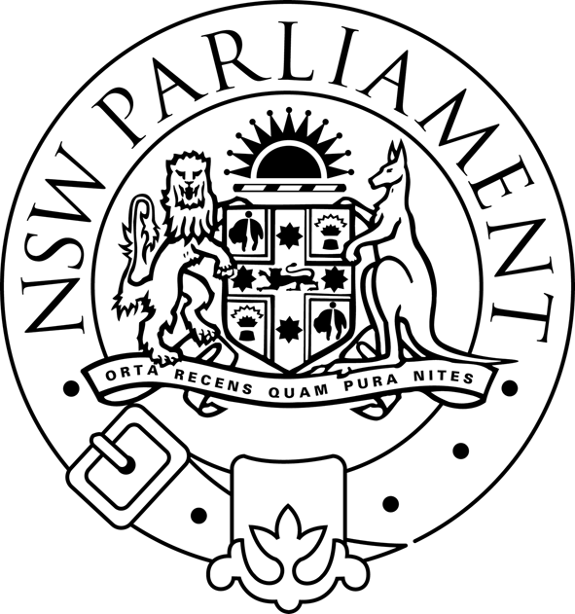
LEGISLATIVE ASSEMBLY
Standing Committee on Natural Resource Management

PUBLIC HEARING

TERMS OF REFERENCE C AND D

(land use management approaches to reduce
salinity and mitigate drought)

WEDNESDAY 6 APRIL 2005

11.00 am – 12.30 pm

WARATAH ROOM

Time | Organisation | Witnesses
11.00 am - 11.40 am |  | Brian Binning  Landholder
11.40 am - 12.30 pm | Landcare Australia Limited | Brian Scarsbrick  Chief Executive  Jenny Quealy  Partnership Development Manager

