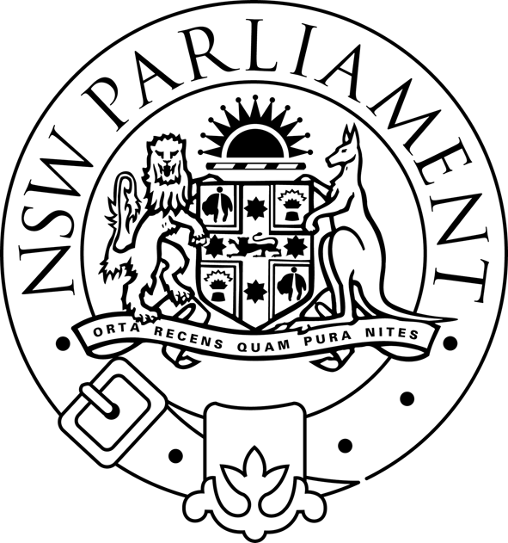
LEGISLATIVE ASSEMBLY
Standing Committee on Natural Resource Management

PUBLIC HEARING

TERMS OF REFERENCE C AND D

(land use management approaches to reduce
salinity and mitigate drought)

THURSDAY 7 APRIL 2005

11.00 am – 1.00 pm

ROOM 1153

Time | Organisation | Witnesses
11.00am – 11.45 am | Berrigan Shire Council  Bland Shire Council  Wagga Wagga City Council | Rowan Perkins  General Manager  Frank Zaknich  General Manager  Ian Neave  Manager, Natural Environment
11.45am – 12.15 pm | Namoi CMA | Bruce Brown  General Manager
12.15 pm – 1.00 pm | National Landcare Council; Hawkesbury/Nepean CMA | John Klem  Member NLC and Chairperson H/N CMA

