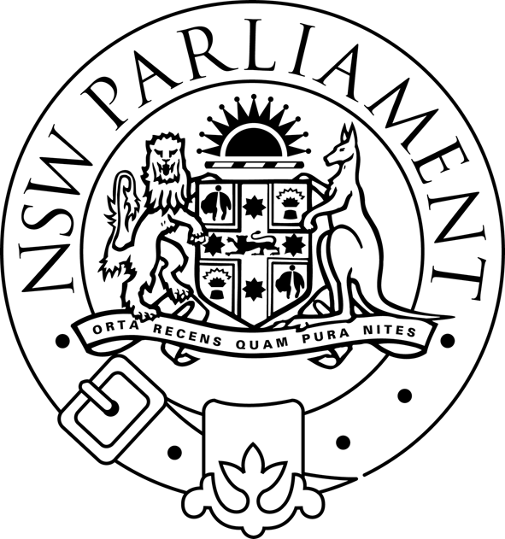
LEGISLATIVE ASSEMBLY
Standing Committee on Natural Resource Management

PUBLIC HEARING

TERMS OF REFERENCE C AND D

(land use management approaches to reduce
salinity and mitigate drought)

WEDNESDAY 23 MARCH 2005

11.00 am – 1.00 pm

WARATAH ROOM

Time | Organisation | Witnesses
11.00am-noon | Dept of Primary Industries | Dr Richard Sheldrake  Deputy Director General, Agriculture and Fisheries  John Fisher  Manager, Natural Resources Advisory Services  Len Banks  Director,  Regional Relations and Education
Noon – 1.00pm | Western Catchment Management Authority  Namoi Catchment Management Authority | Rory Treweeke,  Chairperson  Daryl Green,  General Manager  George Truman  Salinity Officer

