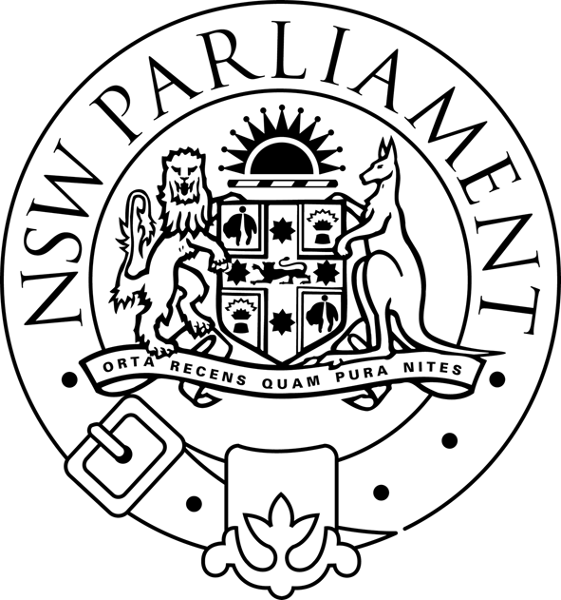
LEGISLATIVE ASSEMBLY
STANDING COMMITTEE ON NATURAL RESOURCE MANAGEMENT
Parliament of New South Wales · Macquarie Street · Sydney NSW 2000 · Australia

Notice of Public Hearing

Inquiry into Natural Resource Management Issues

Thursday 4 September 2003, from 10:00am

Room 1108, Parliament House

Time: | Witness | Organisation:
10:00 | Dr Chris Guest, Acting Deputy Director General  Mr Des Cleary, General Manager, Water Management Act Implementation | Department of Infrastructure, Planning & Natural Resources
12:00 | CLOSE

For further information please contact Mervyn Sheather on tel. 9230 2096.

