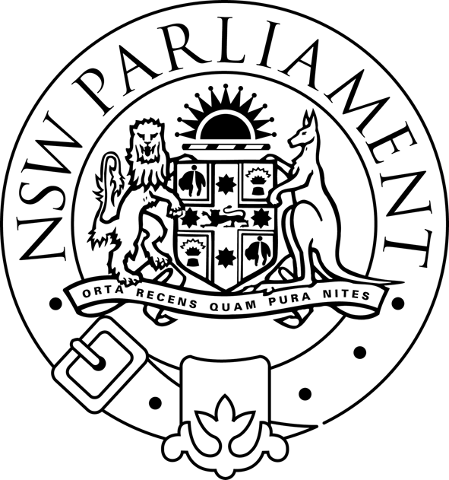
LEGISLATIVE ASSEMBLY
STANDING COMMITTEE ON NATURAL RESOURCE MANAGEMENT
Parliament of New South Wales · Macquarie Street · Sydney NSW 2000 · Australia

Notice of Public Hearing

Inquiry into Natural Resource Management Issues

Friday 5 September 2003, from 10:00am

Room 1108, Parliament House

Time: | Witness | Organisation:
10:00 | Mr Doug Miell, Executive Director  Ms Jacqueline Knowles, Policy Analyst | NSW Irrigators Council
12:00 | CLOSE

For further information please contact Mervyn Sheather on tel. 9230 2096.

