To the Members of the

Legislative Assembly Public Accounts Committee

State Plan Reporting

“The Committee recommends improvements to the efficiency and effectiveness of government activities. A key part of Committee activity is following up aspects of the Auditor-General’s reports to Parliament. The Committee may also receive referrals from Ministers, the Legislative Assembly and the Auditor-General to undertake inquiries.”

We commend the Government and its reviewing committees on the broad based community consultation process involved in the management of the state’s resources.

We appreciate the opportunity to be able to make comment in the process of governance and are willing to address the committee in person to state further our case and to present substantial, information and evidence not included with this submission.

We will submit the issues raised in this submission (in moderated form) to other relevant agencies, as a mode of advocacy, for this issue to be addressed and which we believe is a natural follow-on from the Masters’ review of the HSC, which RECOMMENDED Standards Based Reporting to be implemented by the end of 2006. This reporting issue relates to the assessment practices, in place at relevant schools as opposed to, the Plain English Reporting, currently encompassed in the DET-School Education- SBSR REPORTING SOFTWARE PACKAGE. We believe this should also include standards based assessment PRACTICES AND PROCEDURES, which are apparent and transparent to students and parents.

We submit these comments and suggestions in relation to the specific area of the State Plan “Students fulfill their potential with increasing levels of attainment for all students Priority S4,” as a consequence of our experiences at grass roots level and currently within the high school framework.

We acknowledge that currently specific targets within this arena are being addressed, (Reading Recovery, Aboriginal programs) but point this issue concerns all students within the years 7-12 High School arena and therefore impacts on both parents and students within this priority area.
We offer the following statements from the State Plan online pdf file, to support our comments and submission, regarding equal opportunity to achieve the outcomes of fulfilling individual potential during the process of education when at high school. as follows:
“A review of the plan involving the community every two to three years to revise and refine our priorities” and “The Government will provide long-term funding commitments to key programs that support the priorities – giving agencies more certainty and flexibility in committing to program roll out.”

Therefore, we take our direction for this submission, based on the summarized and highlighted points, from within the State Plan and our summary of such, as detailed in, Appendix 1.

We request, that the following comments and suggested approaches to address what we perceive to be a “gap” in the satisfactory delivery of transparent assessment processes be available in a universal mode. Possibly, as online resources developed co-jointly by BOS and DET personnel, for all tasks within subjects, and for all class groups so that students and teachers have a common framework to work from i.e. “everyone is working from the same page” This then would help to reduce the perception of unfairness within the assessment practices conducted within and between schools,

and increase the degree of transparency and chance of misreporting/ “measuring” of students performance.

We acknowledge that we do not have the knowledge, experience, or story of every school process every teacher’s plan and professional judgment and every student’s experience. However, from our professional knowledge and personal experience, we believe that this process varies in the degree of successful implementation, dependent on individual school policies, quality of teacher professional judgment at the junior high school level and the quality of the processes applied in addressing the BOS REQUIREMENTS at senior high School level.

We suggest that changes to a more transparent process of within-school assessment practices may include the following aspects:

Within-school assessment procedures and practices and their translation to the currently operating transparent reporting processes be uniform in scaffold/framework structure( refer examples appendix 2-8).

that the external requirements of the BOS within high schools be more efficiently implemented using the frameworks as suggested by the BOS for within school assessment processes be a mandate not a guideline for THE EXTERNALLY EXAMINABLE ASSESSMENTS YEARS 9-12

that a strong link be established through BOS AND DET operating committees that SUCH THAT WORKING PARTIES BE ENABLED TO DEVELOP standardized SCAFFOLDS AND FRAMEWORKS THAT TEACHERS PARENTS AND STUDENTS CAN PLAINLY UNDERSTAND AND USE WITHIN AND BETWEEN SCHOOLS

That these comments be considered as a future funded and supported priority through this committees review process and recommendations

From these statements we take the lead to request a review of the assessment practices and procedures undertaken at high school level in order that

THESE ASSESSMENT PRACTICES AND PROCEDURES BE:

More meaningful to parents and students,

Transparent to parents and students,

Equitable in number, scope and content as recommended by the BOS,

Transparent both in presentation, structure, measurement and feedback so that no one student, class cohort, subject cohort, or school is advantaged or disadvantaged through unequal implementation processes and thereby unequal opportunity for equality of outcomes.

We request that frameworks and scaffolds be provided as an online resource to minimize teacher “paperwork” overload and provide suggested examples already available from the BOS, (appendix 2-8).

We request such online resources be available to schools in a standardized format that can be downloaded by teachers, faculties, executive staff, so that uniformity within and between schools occurs and assessment policies of schools may be more readily implemented.

Further, through our current experiences we believe this gap occurs at the point of communication between teacher-student and parents.

That the school-based instruction, syllabus delivery, outcomes assessment, and reporting/feedback to students and the level of transparency varies in such a manner as to raise concerns of unequal opportunity dependent on a the school attended.

That the process of standardizing assessment practices is readily “fixed”.

That the “measurement”, recording and reporting of student achievements at each point of the instruction process, within individual schools, varies greatly making transference between schools a difficulty for student unfamiliar or experiencing a lack of professional clarity in the assessment process, at their current school.

We acknowledge that there are many exceptional and sound practices in place at different schools. That many teachers undertake the professional training programs provided, that involve training in standards based marking practices for the basic skills tests ELLA, SNAP and ESSA, PROGRAMS, as well as the BOS, HSC trained markers programs.

The professional development, in standards based marking which enables schools and teachers within those schools to carry forward these practices into their personal assessment practices is also evidenced in the Basic Skills processes for year 3-6,The Ella, Snap and ESSA projects for years 7-8. However, we believe that the development and implementation of a standards framework fro assessment practices within schools, will best address the disparities and counter the potential for variation in practices that can result in unequal opportunity experienced by students attending different schools.

It would seem to us that those schools, where “standards” trained teachers work or where those schools who employ a standards framework for their, within school assessments, are better able, to provide a structured framework, that both parents and students are able to work with. This procedure thereby provides a more transparent assessment process, which in itself eliminates the perceptions, of nepotism or unjust practices.

We acknowledge that teacher professional judgment and school policies specific to individual communities is still relevant. However, we believe that a greater standardization of the assessment tools/ scaffolds would enable greater transparency of the school based assessment practices, thereby eliminating the potential for miscommunication, lack of communication and more directly engages both parents and students in taking responsibility for their educational outcomes other than those that are unequal due to limitations in the delivery process. This in turn translates into “best practice” between the Board of Studies and DET-School Education.

With thanks for your time in viewing our submission,

Jane and Johan van Woerkom

Appendix 1

Introduction

The NSW Government has a profound impact on the lives of the nearly seven million people who live in NSW
The State Plan sets out the goals, the community wants the NSW Government to work towards.
It identifies priorities, for Government action that will help achieve each of these goals over the next 10 years. Targets have been set where possible.
The plan does not cover everything the State Government does. This plan sets out the priorities on which we will focus our efforts for improvement.
The State Plan is not just a plan for the NSW Government; it is a plan to involve everyone in helping us respond to the challenges and opportunities we all face.

Delivering Better Services –
key services to the whole population including health,
education
and transport

Involving the Community

The State Plan is the product of an extensive consultation process speaking to 4000 people across NSW, including rural and regional areas.
An additional 50,000 people commented on the priorities for Government through the State Plan website.

Delivering the Plan

Stronger Accountability
To strengthen accountability across Government, the State Plan introduces:
Targets – clear, measurable goals for the future
Lead Ministers and Agencies – one lead Minister and agency responsible for delivering each target across Government with lead agency CEO performance agreements directly with the Premier
Publication of data on the State Plan website as it becomes available
External members on the State Plan Cabinet Committee to bring private sector expertise on improving performance
A State Plan Annual Report which reports on our progress
A review of the plan involving the community every two to three years to revise and refine our priorities

Decisions for the Long Term

The Government will provide long-term funding commitments to key programs that support the priorities – giving agencies more certainty and flexibility in committing to program roll out.

The State Plan will be fully integrated with every State Budget.
The annual budgeting cycle will commence with a priority setting process that reviews current performance on State Plan priorities relative to targets.

THE STATE PLAN UNDER REVIEW

Chapter 3: Delivering better services

Students fulfill their potential with increasing levels of attainment for all students

Priority S4:

Students who fulfill their potential through schooling and training are in the best position to lead satisfying and rewarding lives.
Improving education outcomes , increases work and employment outcomes and lifts the overall economic and social outcomes for the State.

Targets
By 2008, reduce the number of lowest-performing students in literacy and numeracy in Years 3, 5 and 7 by 10 percent, with a further 20 percent reduction by 2016.
By 2012, increase the number of students in Years 3, 5 and 7 meeting or exceeding national proficiency benchmarks for literacy and numeracy by 20 percent with a further 5 percent increase by 2016.
A baseline for performance improvement in the National Proficiency Benchmarks will be created in 2008 when new national reading and numeracy tests are introduced.

Progress
Source: National Report on Schooling in Australia, MCEETYA

In education, both national and international comparisons show that our students are high performers in international maths, science and literacy tests. Results include:
Highest State in Australia for Years 4 and 8 maths, in the international TIMSS test.
Highest State in Year 8 science in TIMSS.
NSW 15 year olds are near the top of the international rankings for reading in the OECD PISA test.
In 2006 NSW had the best numeracy results for Year 5 in the NSW Basic Skills Test since testing began.

Recent Actions
New initiatives to improve student performance in literacy and numeracy:
Employ an additional 200 extra Reading Recovery teachers over four years to provide intensive, high quality assistance to 2000 Year 1 students in 200 schools to improve their literacy skills.
Providing a comprehensive range of state literacy support materials for teachers to download online.
Making 19,000 resources with over 50,000 links available online for all teachers.
Developing three new information pamphlets to help primary school parents support their child’s numeracy development including new online resources for parents.
Providing professional development for regional literacy and numeracy teams.
Developing a module to help beginning teachers to teach literacy.
Implementing the Aboriginal Education and Training Strategy to create an environment of high expectations for all Aboriginal students underpinned by a focus on quality teaching to increase literacy and numeracy outcomes.
Implementing the Schools in Partnership initiative in 30 schools with significant Aboriginal student enrolments. The initiative will improve attainment levels for Aboriginal students by developing personalised learning plans, strengthening respect for Aboriginal culture, improving partnerships with Aboriginal communities and supporting quality teaching.
Providing clear information to parents on their child’s school achievement through new ‘plain English’ report cards.

Appendix 2

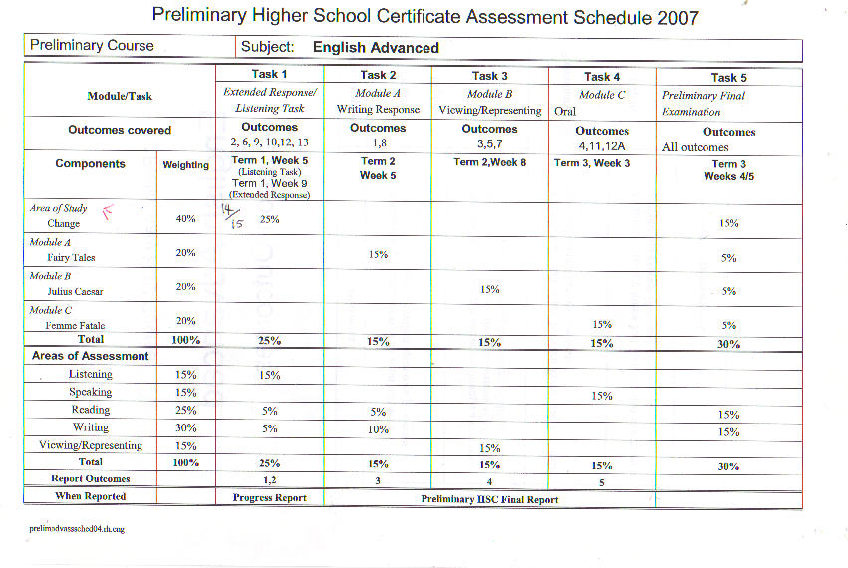

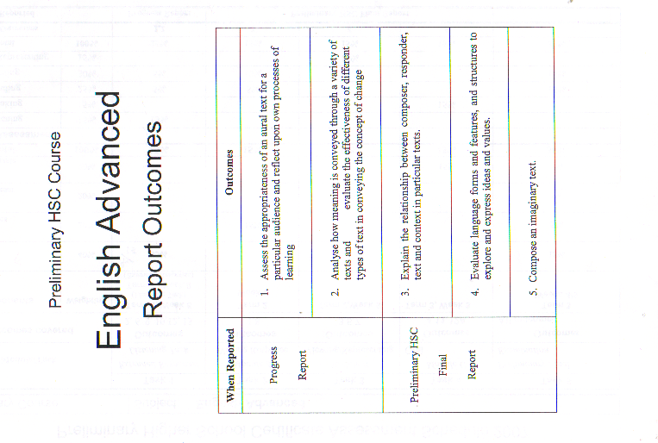

Appendix 3
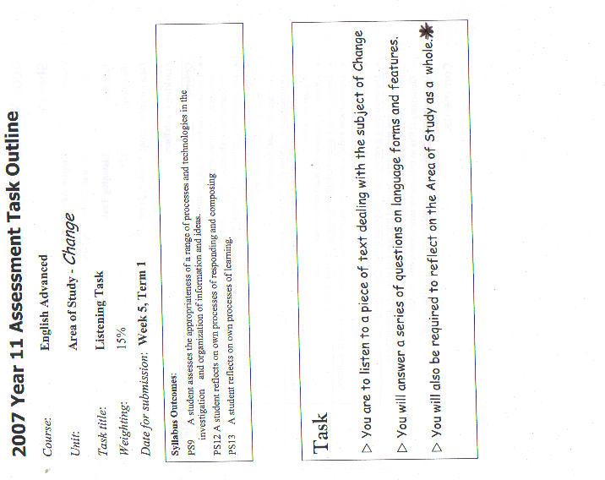
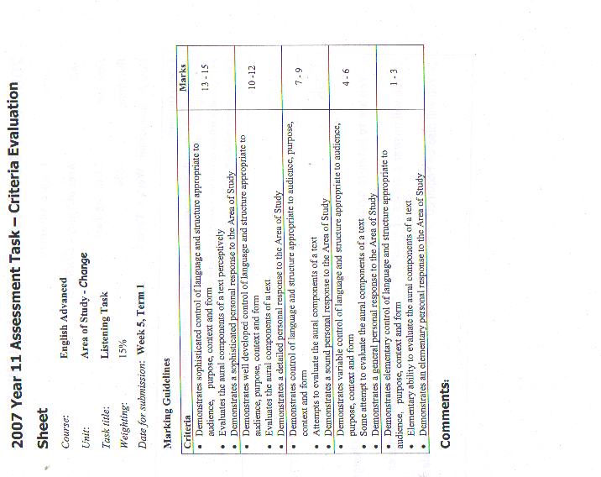
Appendix 4
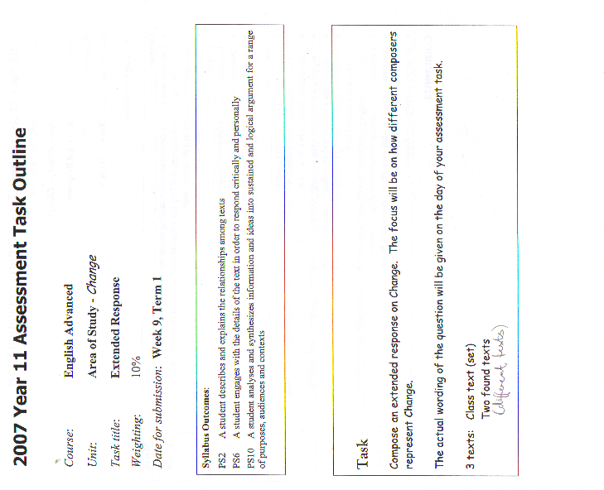
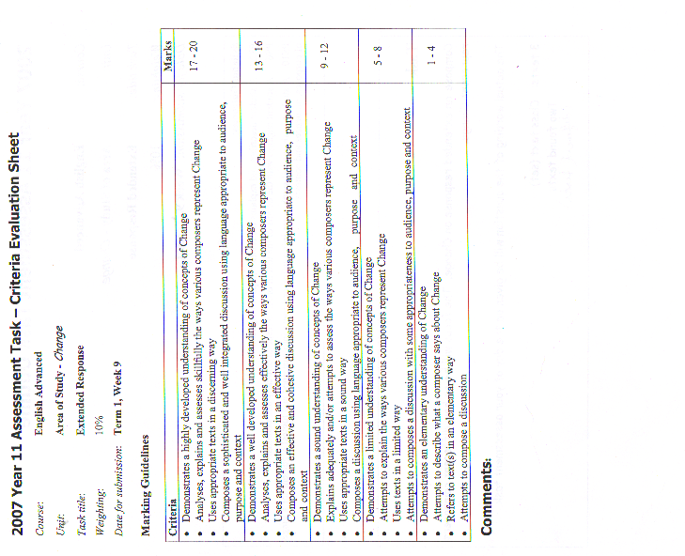
Appendix 5
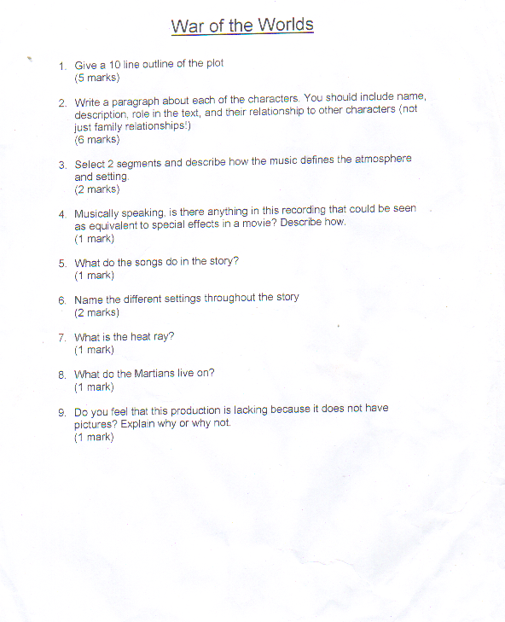
Appendix 6

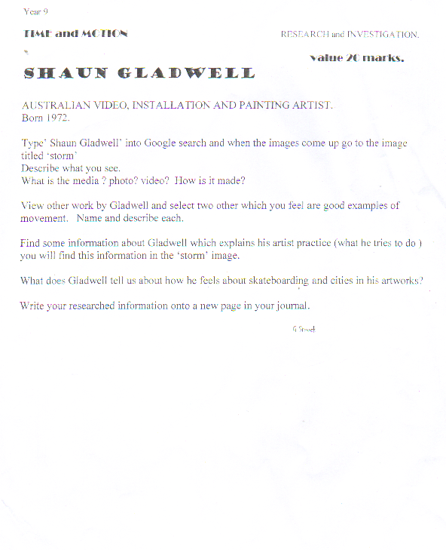

Appendix 7

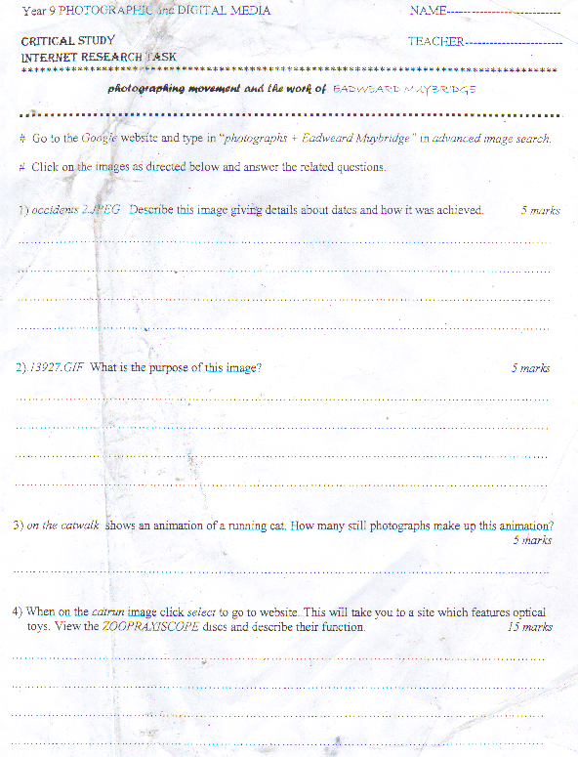

Appendix 8

