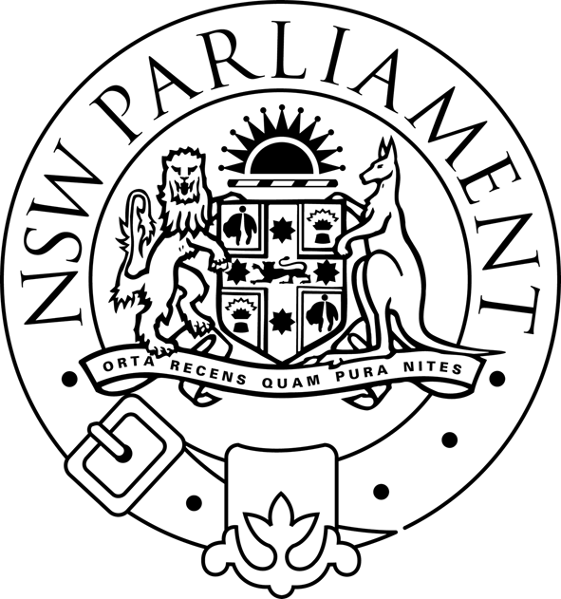
LEGISLATIVE ASSEMBLY
Public Accounts Committee
Parliament of New South Wales · Macquarie Street · Sydney NSW 2000 · Australia

FIRE SERVICES - PUBLIC ACCOUNTS COMMITTEE HEARINGS ON FINANCIAL MODELLING

The Public Accounts Committee will hold its final public hearings as part of its review of the funding of fire services on Wednesday 5 May and Friday 7 May (see schedule).

In March, the Committee launched a report by Professional Financial Solutions (PFS) into financial modelling of different funding systems for fire services. This report compared the costs for residential and commercial property owners of current arrangements to the costs of introducing a levy on property.

The Committee’s Chairman, Matt Brown MP, said “I am pleased that the Committee received 18 submissions in response to the interim report by PFS.

“Now that everyone has had a chance to respond, the Committee has asked PFS to prepare a final report.

“The Committee looks forward to taking evidence from PFS about their work and what it shows about fairly funding fire services.

“Before developing our final recommendations, the Committee has also decided to take further evidence from key stakeholders about the best way of funding fire services.”

Greg Mullins, the NSW Fire Brigades Commissioner and Phil Koperberg, the Rural Fire Services Commissioner, will appear before the Committee on Wednesday.

On Friday, the Committee will take evidence from representatives of Professional Financial Solutions, the Insurance Council of Australia, the Property Council of Australia and the Local Government and Shires Associations of NSW.

The Committee has received 85 submissions to this inquiry so far. After these hearings it will finalise its report.

Media contact: Matt Brown MP on 0409 236 288 4 May 2004

