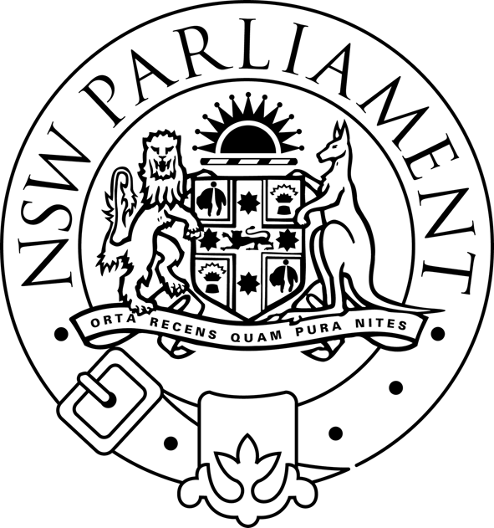
NSW LEGISLATIVE ASSEMBLY

PUBLIC BODIES REVIEW COMMITTEE

FOLLOW-UP REVIEW OF PERFORMANCE AUDIT REPORT ON CORPORATE GOVERNANCE
The Public Bodies Review Committee is charged with examining the annual reports of all public bodies and to enquire into and report on any matter arising from the annual report concerning the efficient and effective achievement of the agency’s objectives. As part of this process the Committee is conducting a follow-up review of the Auditor-General’s Performance Audit Report on corporate governance. The Terms of Reference of the review are:
- To conduct a follow-up review of the implementation of the recommendations contained in the Auditor-General’s Performance Audit Report (1997): Volume One – Corporate Governance in principle and Volume Two – Corporate Governance in Practice and also the application of the Audit Office’s “Guide Towards Better Practice in Public Sector Corporate Governance” by New South Wales Agencies.
- To examine, as part of the follow-up review, the following specific matters:
- Whether the existing corporate governance frameworks and arrangements are appropriate and effective in view of the significant reforms which have transformed the Public Sector in recent years particularly in the areas of the delivery of government service
- Whether the existing boards and committees add value to government and whether any further improvement and rationalisation are required
- Whether the existing arrangements for monitoring and reporting on corporate governance issues and for assessing the performance of boards and committees are effective
- What issues and problems are faced by agencies in implementing effective corporate governance arrangements
- To review the appropriateness of risk management and incentives under the Treasury Managed Fund
- Any other related matters.

The Public Bodies Review Committee invites written submissions from interested organisations, groups or individuals. Submissions should be in writing, typed or on disk and may be addressed to:

Committee Manager
Public Bodies Review Committee
Parliament House
Macquarie Street
SYDNEY NSW 2000

Alternatively, submissions may be sent by FAX to (02) 9230 3052, or by e-mail to awatson@parliament.nsw.gov .au.

The closing date for submissions is 5 September 2003.

For further information contact Catherine Watson on (02) 9230-2036

Milton Orkopoulos MP
Chairman

