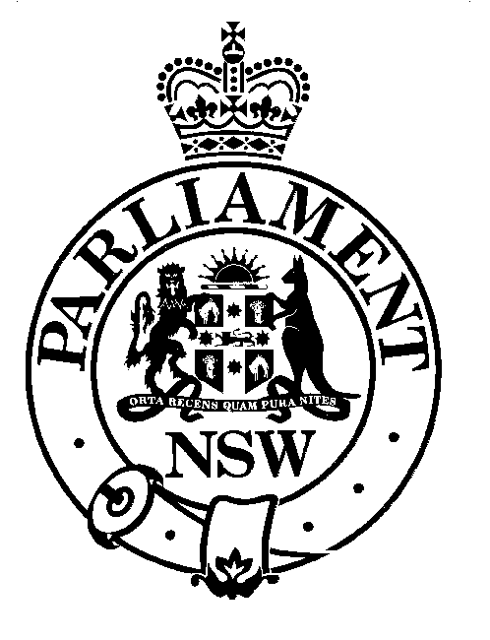

Public Accounts Committee to question Auditor-General

The Public Accounts Committee of State Parliament is to question the NSW Auditor-General on the operation of his Office on Thursday, 6 June 2002 in the Jubilee Room of Parliament House at 4 pm.

In announcing the public hearing, the Chairman of the Public Accounts Committee, Fairfield MP Joe Tripodi, said “The PAC has a statutory responsibility to appoint a reviewer of the Audit Office every three years. The PAC takes seriously its responsibility to safeguard the public interest by ensuring the public audit office is equipped to handle the accountability challenges of the 21st century.”

“In recent times the role of auditors has come under scrutiny in both the public and private sector. The public’s expectations on the role of the public sector auditor has only increased as the ordinary taxpayer considers that HIH, One-Tel and Ansett collapsed after receiving clear audit reports the year before.”

“The PAC views the Auditor-General as the financial early warning system for NSW taxpayers. We need an assurance that not only did last year’s accounts pass the auditors green pen but we need, and indeed deserve, an assurance that the performance of government agencies minimises risk and ensures efficiency and effectiveness in their operations.”

“The PAC will not be dwelling on the past. We will be looking to ensure that the Auditor-General has the right mix of staff and resources to do the job in the future.”

“We will, however, be looking at procedural fairness in the conduct of performance audits. We don’t want government agencies to be distracted by media reports on matters that should have been resolved during the audit process - not debated in the media after the report is tabled in Parliament.”

“We will be asking the Auditor–General for an assurance that the recent spate of collapses in the private sector is unlikely to happen in the NSW government sector” Mr Tripodi concluded.

Mr Tripodi is available for media comment on 9230 2394.

5 June 2002

